Linux File Hierarchy Structure

The Linux File Hierarchy Structure or the Filesystem Hierarchy Standard (FHS) defines the directory structure and directory contents in Unix-like operating systems.It is maintained by the Linux Foundation.

* In the FHS, all files and directories appear under the root directory /, even if they are stored on different physical or virtual devices.
* Some of these directories only exist on a particular system if certain subsystems, such as the X Window System, are installed.
* Most of these directories exist in all UNIX operating systems and are generally used in much the same way; however, the descriptions here are those used specifically for the FHS, and are not considered authoritative for platforms other than Linux.

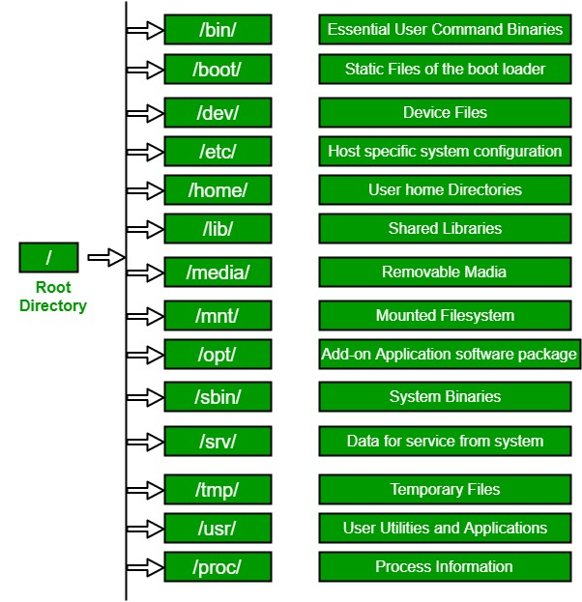

**1. / (Root) :**Primary hierarchy root and root directory of the entire file system hierarchy.

* Every single file and directory starts from the root directory
* Only root user has the right to write under this directory
* /root is root user’s home directory, which is not same as /

**2. /bin :**Essential command binaries that need to be available in single user mode; for all users, e.g., cat, ls, cp.

* Contains binary executables
* Common linux commands you need to use in single-user modes are located under this directory.
* Commands used by all the users of the system are located here e.g. ps, ls, ping, grep, cp

**3. /boot :**Boot loader files, e.g., kernels, initrd.

* Kernel initrd, vmlinux, grub files are located under /boot
* Example: initrd.img-2.6.32-24-generic, vmlinuz-2.6.32-24-generic

**4. /dev :**Essential device files, e.g., /dev/null.

* These include terminal devices, usb, or any device attached to the system.
* Example: /dev/tty1, /dev/usbmon0

**5. /etc :**Host-specific system-wide configuration files.

* Contains configuration files required by all programs.
* This also contains startup and shutdown shell scripts used to start/stop individual programs.
* Example: /etc/resolv.conf, /etc/logrotate.conf.

**6. /home :**Users’ home directories, containing saved files, personal settings, etc.

* Home directories for all users to store their personal files.
* example: /home/kishlay, /home/kv

**7. /lib :**Libraries essential for the binaries in /bin/ and /sbin/.

* Library filenames are either ld* or lib*.so.*
* Example: ld-2.11.1.so, libncurses.so.5.7

**8. /media :**Mount points for removable media such as CD-ROMs (appeared in FHS-2.3).

* Temporary mount directory for removable devices.
* Examples, /media/cdrom for CD-ROM; /media/floppy for floppy drives; /media/cdrecorder for CD writer

**9. /mnt :**Temporarily mounted filesystems.

* Temporary mount directory where sysadmins can mount filesystems.

**10. /opt :**Optional application software packages.

* Contains add-on applications from individual vendors.
* Add-on applications should be installed under either /opt/ or /opt/ sub-directory.

**11. /sbin :**Essential system binaries, e.g., fsck, init, route.

* Just like /bin, /sbin also contains binary executables.
* The linux commands located under this directory are used typically by system aministrator, for system maintenance purpose.
* Example: iptables, reboot, fdisk, ifconfig, swapon

**12. /srv :**Site-specific data served by this system, such as data and scripts for web servers, data offered by FTP servers, and repositories for version control systems.

* srv stands for service.
* Contains server specific services related data.
* Example, /srv/cvs contains CVS related data.

**13. /tmp :**Temporary files. Often not preserved between system reboots, and may be severely size restricted.

* Directory that contains temporary files created by system and users.
* Files under this directory are deleted when system is rebooted.

**14. /usr :**Secondary hierarchy for read-only user data; contains the majority of (multi-)user utilities and applications.

* Contains binaries, libraries, documentation, and source-code for second level programs.
* /usr/bin contains binary files for user programs. If you can’t find a user binary under /bin, look under /usr/bin. For example: at, awk, cc, less, scp
* /usr/sbin contains binary files for system administrators. If you can’t find a system binary under /sbin, look under /usr/sbin. For example: atd, cron, sshd, useradd, userdel
* /usr/lib contains libraries for /usr/bin and /usr/sbin
* /usr/local contains users programs that you install from source. For example, when you install apache from source, it goes under /usr/local/apache2
* /usr/src holds the Linux kernel sources, header-files and documentation.

**15. /proc :**Virtual filesystem providing process and kernel information as files. In Linux, corresponds to a procfs mount. Generally automatically generated and populated by the system, on the fly.

* Contains information about system process.
* This is a pseudo filesystem contains information about running process. For example: /proc/{pid} directory contains information about the process with that particular pid.
* This is a virtual filesystem with text information about system resources. For example: /proc/uptime